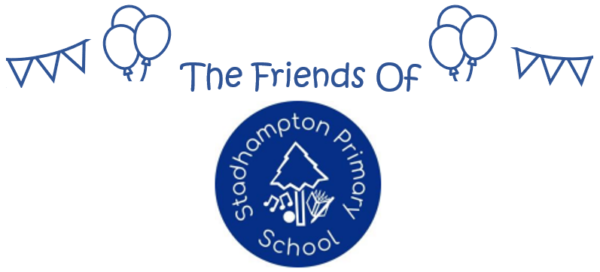

FOSP FUNDING REQUEST FORM
The Friends of Stadhampton Primary (or “FOSP” for short) is a registered charity (charity no. 1201062) established to enrich the education and experiences of the pupils at Stadhampton Primary School. FOSP focuses on 1) assisting in enhancing the learning and development of the children at the school; 2) encouraging closer links between the school, the families of pupils, and the wider community; 3) supporting the school in enriching the overall learning experience for its pupils; and 4) engaging in activities which support the school and its pupils. These are known as the FOSP purposes, and are set out in the constitution.
The FOSP committee (who are trustees for the purposes of the charity) must ensure that each and every funding commitment is made in accordance with the constitution. For this reason, all funding requests should be made formally and via this form.
To request funds please return this form to the FOSP Treasurer, either in person, via the school office, or by email to helloFOSP@gmail.com.

Funding Requested – please provide details of the event, equipment, or activity you are looking to fund

Full cost to the school | FOSP funding requested | FOSP % | Date funds are required
£ | £

Benefits – please provide a brief description of how the event/equipment/activity/project will advance/enrich the education and/or experience of the pupils at the school

Pupil Impact (Please complete as applicable)
Pupil No – Please state number of pupils who will benefit in each year group
Year Group | R | YR1 | YR2 | YR3 | YR4 | YR5 | YR6 | Total

Funding Request submitted by (name) | Request Date | Signed
Guidelines for FOSP funding applications

Funds raised by FOSP are to enable the school to pay for events, activities, projects or equipment outside the normal (core) school budget. This is to ensure that the basic requirements for the education of children are not reliant on FOSP funds, which cannot be guaranteed.

In special circumstances, a core item that would ordinarily be funded by the normal school budget could be considered for FOSP funding if it can be justified in accordance with the FOSP constitution, based on the particular circumstances at the time. Any such approval given would not however form a precedent.

The FOSP committee need to be satisfied that funds are allocated in an effective way that will benefit and support the children; and they will also need to give consideration to funds being spread evenly across the key stages, different academic areas, and extra-curricular activities and interests.

Using this form and the following steps, the aim is to streamline the funding request process both for the School and the FOSP committee.

Steps for funding requests:

- and the request form must be completed, signed, and dated on behalf of the school
- Completed forms should be passed to the FOSP Treasurer, either in person or by email.
- Each request will be considered at the next scheduled FOSP committee meeting – meeting dates will be communicated to the school office as far in advance as possible
- The FOSP committee will respond to each request either (i) approving it, (ii) declining, or (iii) with queries/requests for further information
- All requests need to be approved by a majority of the FOSP committee before funding can be confirmed.

Each request for funding will be considered on an individual basis, and successful requests should not be seen as setting a precedent.

FOSP COMMITTEE USE
Decision (Please tick as appropriate)
Approved | Declined | Deferred/More consideration needed |  | Date of Decision
Are any Grants available/potentially available?
Comments
Signed: FOSP Chairperson/Secretary |  |  | Signed: FOSP Treasurer

